

**Electrical Circuit (CSE209)**

Lab Report

Experiment – 3

Submitted to

**M. Saddam Hossain Khan**

Senior Lecturer

Department of Computer Science & Engineering

Submitted by

Name: **Ishfaf Zaman Khan Pre-Lab Marks**:

Student ID: **2023-3-60-338 Post-Lab Marks**:

Section: 02 **Total Marks:**

Date: 25th March, 2025

**Experiment Name: Bias Point Details Analysis of DC Circuit with Independent Sources Using PSpice Schematics.**

**Objectives:**

1. To learn the fundamentals of PSpice

2. To analyze the Bais Point Detail of the DC circuit using PSpice schematics.

**Circuit Diagram:**

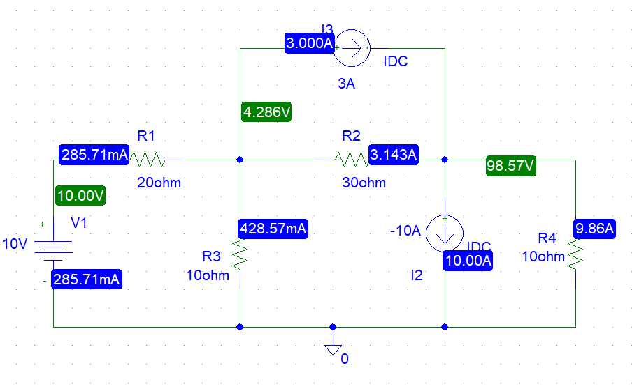

**Figure-2**

**Schematics Netlist:**

I_I3 $N_0001 $N_0002 DC 3A

R_R4 0 $N_0002 10ohm

R_R3 0 $N_0001 10ohm

R_R2 $N_0001 $N_0002 30ohm

R_R1 $N_0003 $N_0001 20ohm

V_V1 $N_0003 0 10V

I_I2 $N_0002 0 DC -10A

**Post-Lab Questions**

**1. Theoretically calculate all the currents and the voltages for the circuit shown in Figure 2.**

Solution:

From figure 02,

𝑖2=-10A

𝑖3= 3A

Now,

As VDC is in between node 1 and 0 so,

V1= 10V

Applying KCL and Ohm’s law at nodes 2 and 3,

$$\frac{10-V_{2}}{20}=\frac{V_{2}}{10}+\frac{V_{2}-V_{3}}{30}+3$$

Or, $\frac{10-V_{2}}{2}-V_{2}-\frac{V_{2}-V_{3}}{3}=30$

Or, $\frac{30-3V_{2}-6V_{2}-2V_{2}+2V_{3}}{6}=30$

$∴-11V_{2}+2V_{3}=150$………(i)

And,

$$\frac{V_{2}-V_{3}}{30}+3=-10+\frac{V_{3}}{10}$$

Or, $\frac{V_{2}-V_{3}}{3}-V_{3}=-100-30$

Or, $\frac{V_{2}-V_{3}-3V_{3}}{3}=-130$

$∴V_{2}-4V_{3}=-390$………(ii)

From (ii),

$V_{2}=-390+4V_{3}$………(iii)

Substituting V2 = -390+4V3 in equation (i),

Or, $4290-44V_{3}=150$

Or, $-42V_{3}=-4140$

$$∴V_{3}=98.57$$

Substituting V3 = 98.57V in equation (iii),

$$V_{2}=-390+4×98.57=4.286V$$

By solving equations (i) and (ii) we get,

V2 = 4.286 V

V3 = 98.57V

Now,

So the values are,

𝑖1 = 258.7mA

𝑖2 = -10A

𝑖3 = 3A

𝑖4 = 9.858A

𝑖5 = -3.143A

𝑖6 = 428.6mA

And,

V1 = 10V

V2 = 4.286V

V3 = 98.57V

**2. Compare the theoretical solution of the circuit shown in the figure with the solutions obtained from PSpice.**

Solution:

Comparing values of voltages,

|  |  |
| --- | --- |
| **PSpice** | **Theoretical** |
| **V1 = 10 V** | **V1 = 10 V** |
| **V2 = 4.286 V** | **V2 = 4.286 V** |
| **V3 = 98.57 V** | **V3 = 98.57 V** |

Comparing the values of current,

|  |  |
| --- | --- |
| **PSpice** | **Theoretical** |
| 𝑖1=258.71 mA | 𝑖1=258.71 mA |
| 𝑖2= -10 A | 𝑖2= -10 A |
| 𝑖3= 3 A | 𝑖3= 3 A |
| 𝑖4=9.86 A | 𝑖4=9.86 A |
| 𝑖5= -3.143 A | 𝑖5= -3.143 A |
| 𝑖6=428.57 mA | 𝑖6=428.57 mA |

All the values of currents and voltages we get theoretically, and from PSpice, are equal.

**Discussion:**

1. The components in the schematic must be placed in the correct order, following the circuit diagram.
2. The values of resistances, voltages, and currents should be changed according to the given values in the manual.
3. The circuit should use proper grounding to avoid simulation errors or incorrect results.
4. The applications of PSpice simulation should be learned from this experiment.
5. It is needed to calculate accurately to get the exact theoretical values.

**Conclusion:**

This experiment successfully analyzed the DC circuit's bias point using theoretical calculations and PSpice simulations. The close match between calculated and simulated values confirmed the accuracy of both methods. It also demonstrated the importance of circuit analysis techniques and the usefulness of simulation tools in verifying theoretical results.